Supporting Information:

**Enhanced light-matter interactions in dielectric nanostructures via machine learning approach**

Lei Xu,a, b Mohsen Rahmani,b, c, d, * Yixuan Ma,a Daria A. Smirnova,c Khosro Zangeneh Kamali,c, d Fu Deng,a Yan Kei Chiang,a Lujun Huang,a Haoyang Zhang,e Stephen Gould,f Dragomir N. Neshev,c, d and Andrey E. Miroshnichenkoa,∗

aUniversity of New South Wales, School of Engineering and Information Technology, Canberra, Australia

bNottingham Trent University, School of Science & Technology, Department of Engineering, Advanced Optics and Photonics Laboratory, Nottingham, United Kingdom

cAustralian National University, Research School of Physics, Nonlinear Physics Centre, Canberra, Australia

dAustralian National University, Research School of Physics, ARC Centre of Excellence for Transformative Meta-Optical Systems (TMOS), Canberra, Australia

eQueensland University of Technology, School of Electrical Engineering and Computer Science, Brisbane, Queensland, Australia

fAustralian National University, College of Engineering and Computer Science, Canberra, Australia

*: mohsen.rahmani@anu.edu.au; andrey.miroshnichenko@unsw.edu.au

Contents:

1. **Band structure and near-field distributions of the Si nanobar metasurface**
2. **Forward neural network prediction**
3. **Multipolar structures for three different metasurfaces**
4. **Linear properties and Q-factor estimation for the fabricated metasurface sample**
5. **Experimental setup for nonlinear measurements**
6. **Third-Harmonic Generation**
7. **Estimation of optical response feedback of the mechanical vibration on the metasurface**
8. **Band structure and near-field distributions of the Si nanobar metasurface**

Fig. S1 gives the electric near-fields comparison between the case for y-polarized pump and x-polarized pump incidence. As can be seen, strong electric field confinement and enhancement is obtained for y-polarized pump incidence. No significant electric field enhancement is observed inside the nanostructures for x-polarized pump incidence.

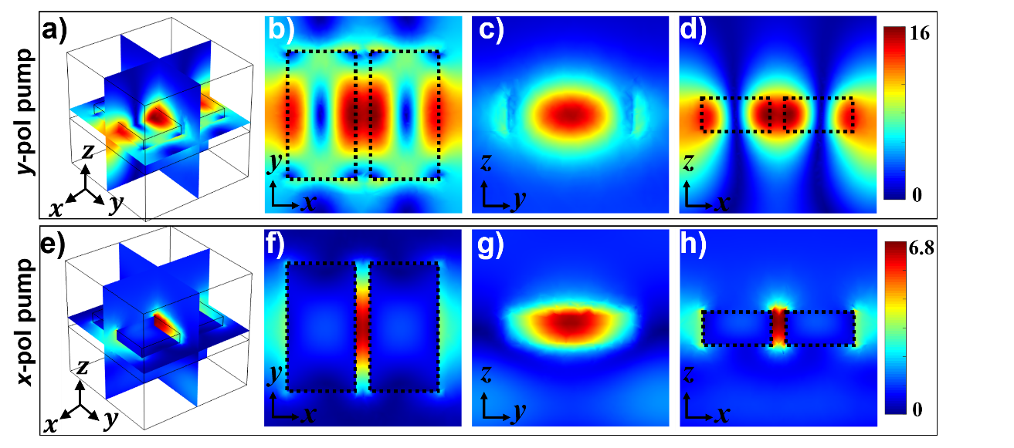

Fig. S1. Electric near-field distributions for Si nanobar metasurface with structural parameters being $w=316 nm$, $L=580 nm$, $x_{0}=189 nm$, under y-polarized pump (a-d) and x-polarized pump (e-h) incidence, respectively.

Fig. S2 shows the calculated band structure for Si nanobars metasurface.

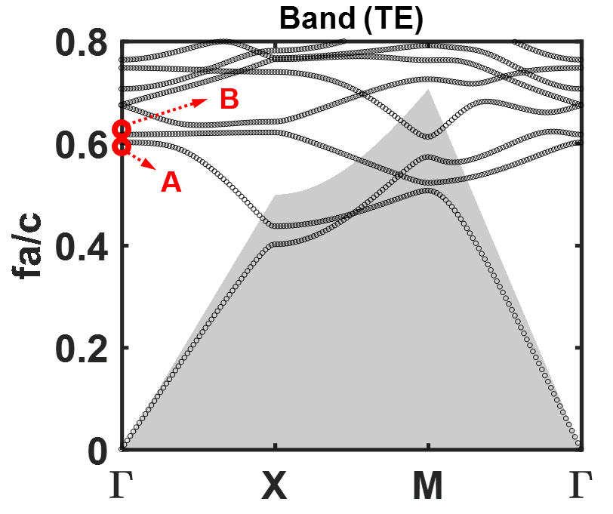

Fig. S2. Calculated band structure of Si two-nanobars metasurface with structural parameters being structural parameters $w=316 nm$, $L=580 nm$, $x_{0}=189 nm$.

Fig. S3 gives the corresponding electric and magnetic near-field distributions for the two modes which originate from the symmetry-protected bound state in the continuum [15,24]: Mode A in the second band and Mode B in the third band at $Γ$ point.

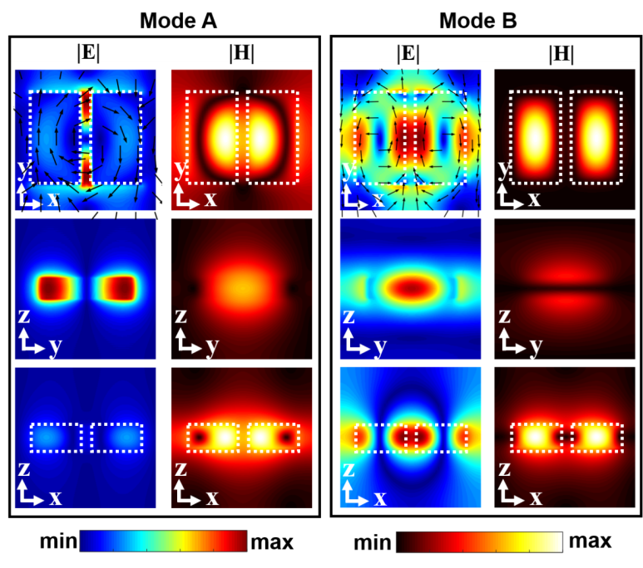

Fig. S3. Calculated electric and magnetic near-field distributions for Mode A in the second band and Mode B in the third band at $Γ$ point (as shown in Fig. S1).

1. **Forward neural network prediction**

Fig. S4 gives three test examples of metasurface design using the forward neural network prediction.

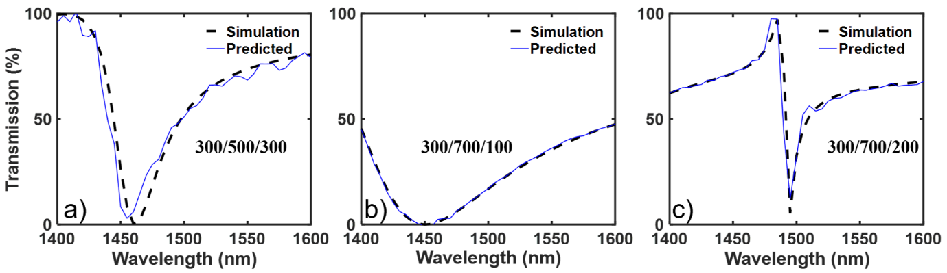

Fig. S4. Forward neural network prediction for three different metasurfaces with structural parameters [$w$, $L$, $x_{0}$] being [300, 500, 300] nm (a), [300, 700, 100] nm (b) and [300, 700, 200] nm, respectively.

1. **Multipolar structures for three different metasurfaces**

Here, we provide the multipolar structures for the three different metasurfaces predicted by the neural network as in Fig. 4(g-i) in the main text. As can be seen, with the decrease of the linewidth, the excitation of electric dipole which formed the leaky channel, become smaller. This will further lead to stronger electric energy confinement and near-field enhancement.

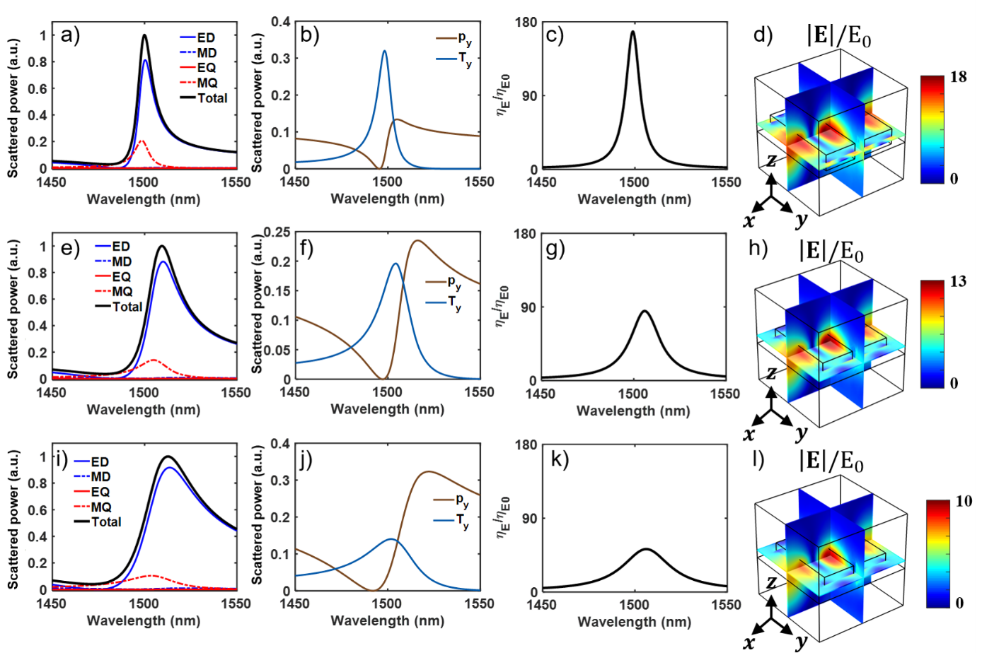

Fig. S5. Multipolar structures for three different metasurfaces as shown in Fig. 4(g-i) of the main text, with the designed Fano parameters being $λ_{0}$ =1500 nm, $q=0.7$, and $∆λ$ =5 nm (a-d), 15 nm (e-h) and 25 nm (i-l), respectively. (a, e, i) Spherical multipolar structures. (b, f, j) Cartesian electric dipole and toroidal dipole mode excitations. (c, g, k) Averaged electric energy density inside the nanostructures. (d, h, l) Electric near-field distributions and enhancements.

1. **Linear properties and Q-factor estimation for the fabricated metasurface sample**

Figure S6 shows the SEM images as well as the measured transmission spectra of the fabricated metasurfaces with targeting resonance wavelength at 1450 nm, 1500 nm and 1550 nm, respectively. We estimated the resonance position $λ_{0}'$ and width $Δλ'$ from the measured transmission spectra by ftting them with Fano line shape formula (Eq. 1 in the main text). The Q-factor was then estimated via formula $Q=ω_{0}/Γ=λ_{0}/Δλ$. Theoretical: $Q\left(1450 nm\right)=96.7$, $Q\left(1500 nm\right)=100$, $Q\left(1550 nm\right)=103.3$. Experimental: $Q\left(1450 nm\right)=104.5$, $Q\left(1500 nm\right)=133.5$, $Q\left(1550 nm\right)=94.2$. As can be seen, the discrepancies between the desired geometrical parameters and the actual dimensions of the fabricated sample, together with a possible minor inhomogeneity of the experimentally deposited silicon film, can affect the experimentally obtained resonance position, linewidth, as well as the Q-factor of the metasurfaces.

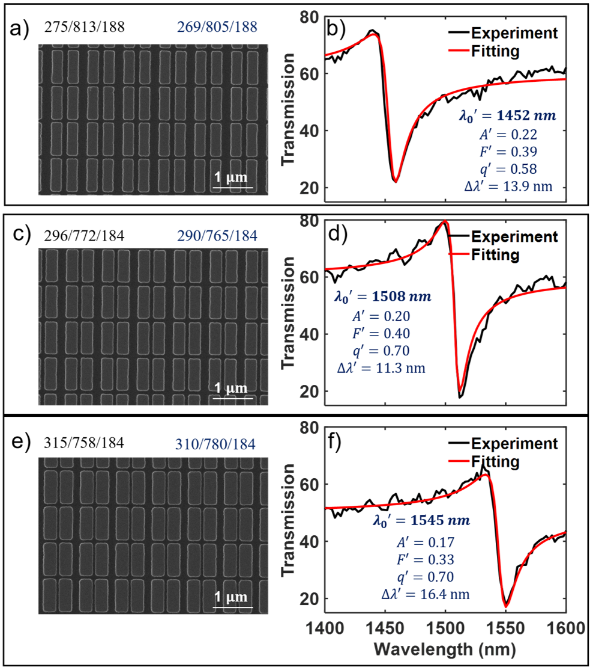

Fig. S6. The SEM images (a, c, e) and experimentally measured transmission spectra fitted with Fano line shape (b, d, f, Eq. 1 in the main text) for the three metasurface samples with designed resonance targeting 1450 nm, 1500 nm and 1550 nm. The desired geometric parameters and the actual dimensions $w/L/x_{0}$ are shown in the top left and top right of the images for each metasurface, respectively. (b, d, f) The measured Transmission spectra and the fitted Fano line shape curves based on Eq. 1 in the main text.

1. **Experimental setup for nonlinear measurements**

The schematic of the experimental setup for the nonlinear measurements is shown below.

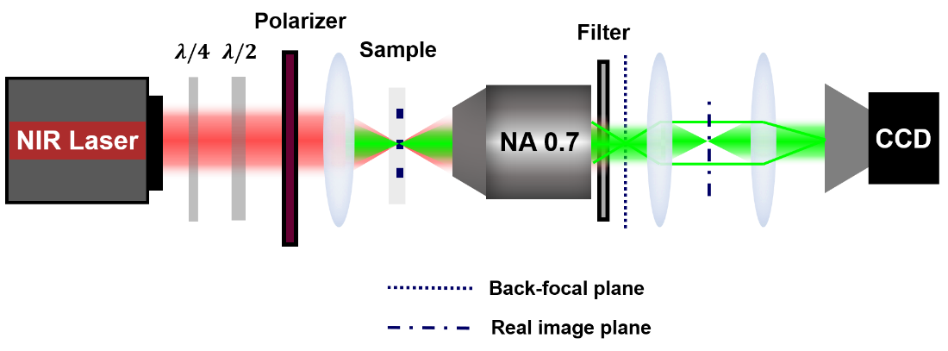

Fig. S7. Schematic of the experimental setup for the nonlinear measurements.

1. **Third-Harmonic Generation**

Fig. S8 shows the experimentally measured THG spectra of the three fabricated samples with targeting resonance wavelength @1450 nm, @1500 nm and @1550 nm, under x-polarized pump illumination.

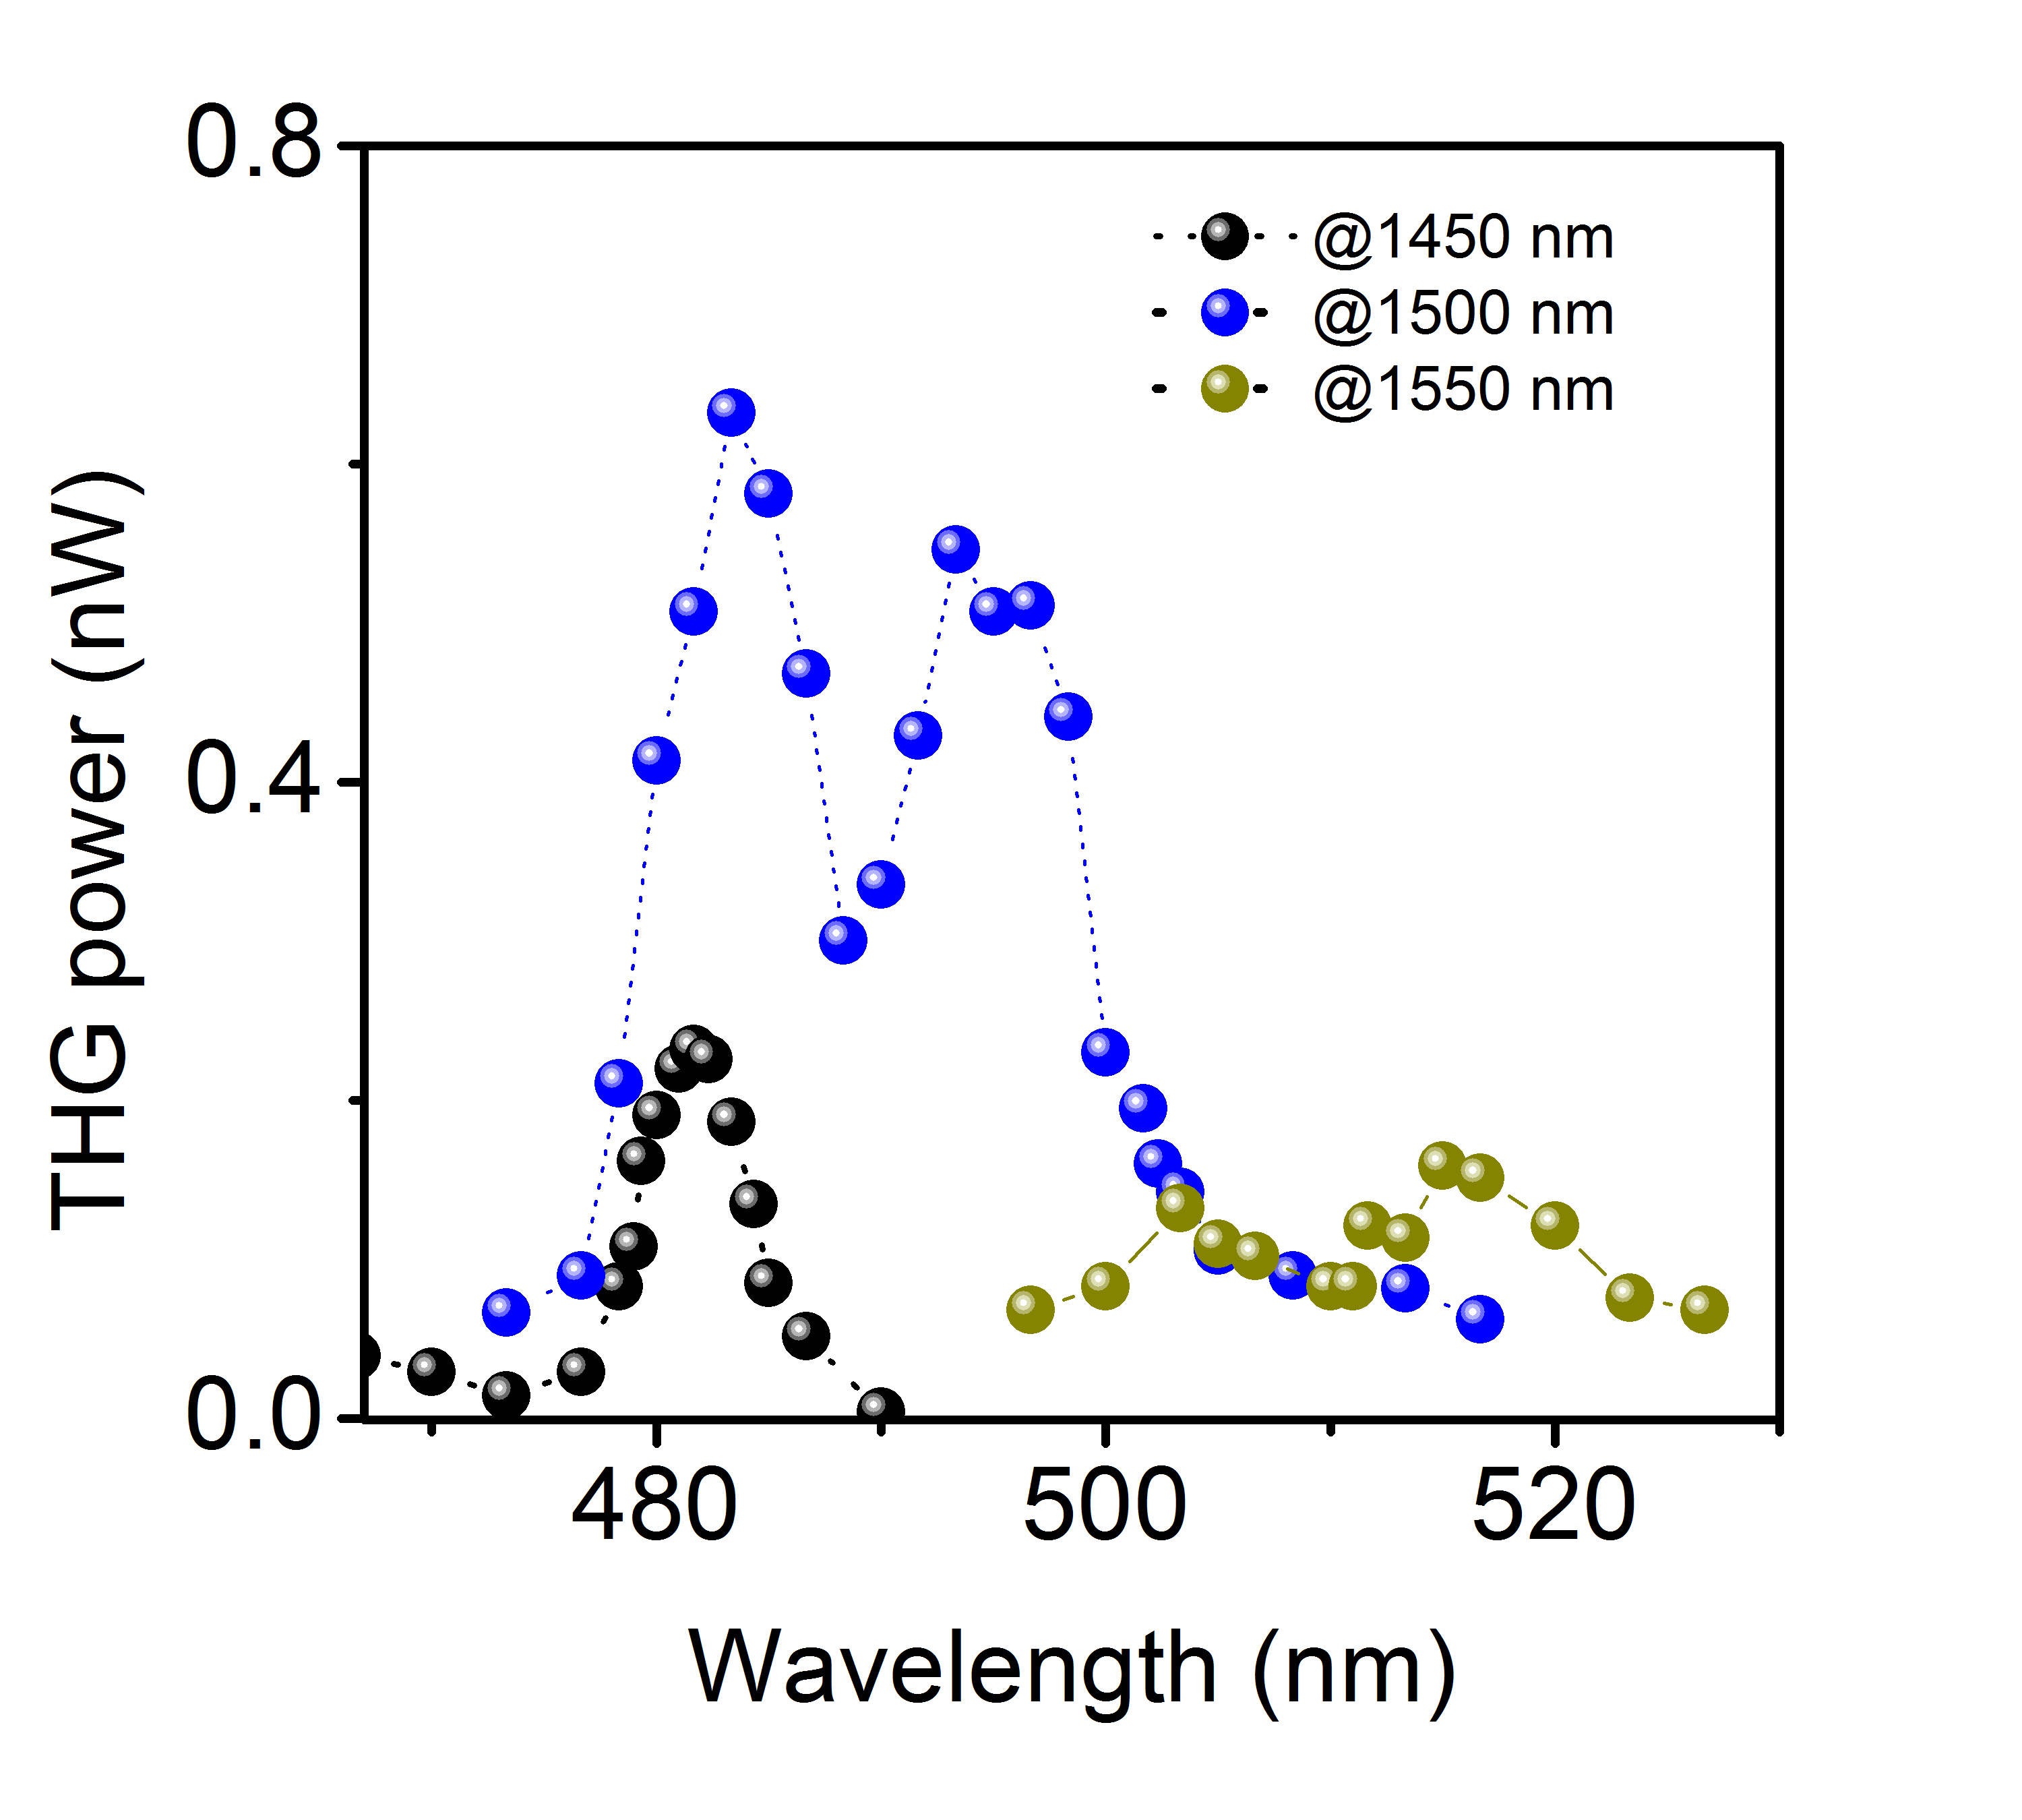

Fig. S8. The experimentally measured THG spectra of the fabricated samples under x-polarized pump illumination.

Figures S9a-c show the experimentally measured forward far-field diffractions of the TH signal from the three metasurfaces at resonance positions. As can be seen, most of the TH signal emit in the two first-order diffractions along the x direction. The zero-order diffraction of TH signal is suppressed. In order to better understand this phenomenon, we performed the nonlinear multipolar analysis as shown in Fig. S9d and 8e. As can be seen, the TH signal is predominant by the TD excitation with small portions of magnetic quadrupole (MQ) and electric octupole (EQ) excitations. These nonlinearly generated multipoles have zero spatial overlap with normal plane wave and have large spatial overlap with outgoing wave of the two first-order diffractions along x direction. This further leads to the suppression of TH radiation in the zero-order diffraction channel, and thus most of the TH signal radiate into the far field through the two first-order diffraction channels along x direction. Furthermore, the theoretical analysis shows that around 30% of the total TH emission goes in the forward direction (Fig. S9f). Based on this, we estimate the total TH conversion efficiency is in the order of ${10}^{-5}$, which is in the same level as compared to the THG emission based on magnetic dipole BIC state as reported in Ref. 15.

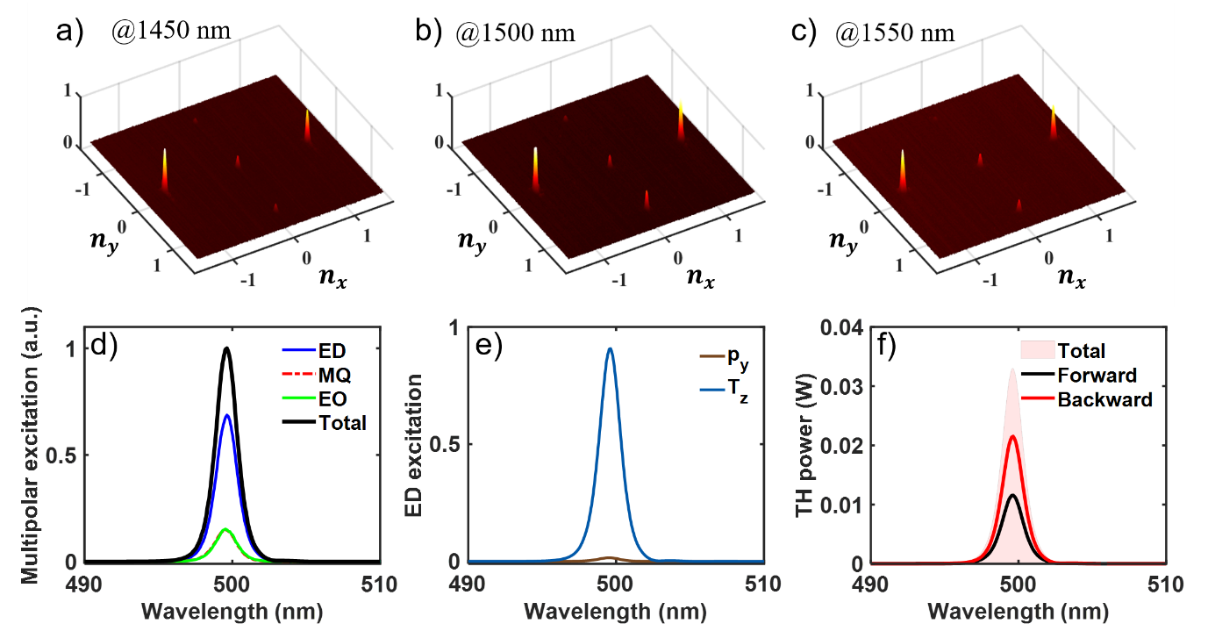

Fig. S9. (a-c) give the experimentally measured forward far-field diffractions of the TH signal for metasurfaces at the resonant positions. d) Calculated spherical multipolar decomposition of the TH signal. e) Calculated Cartesian electric and toroidal dipole modes excitations of the TH signal. f) Calculated total TH emission power from the metasurface.

1. **Estimation of optical response feedback of the mechanical vibration on the metasurface**

According to the transient vibration shown in Fig. 7b of the main text, here we roughly estimate the feedback of the mechanical vibration on the resonant optical response by considering a variation in the width $∆w=50 pm$ and/or length $∆L=25 pm$ of the nanobars in the metasurfaces. Fig. S10 shows the corresponding calculated Transmission spectra. As can be seen, around 4.5% modulation of the transmission intensity is obtained at the sharp edge of the spectrum curve near the resonance.

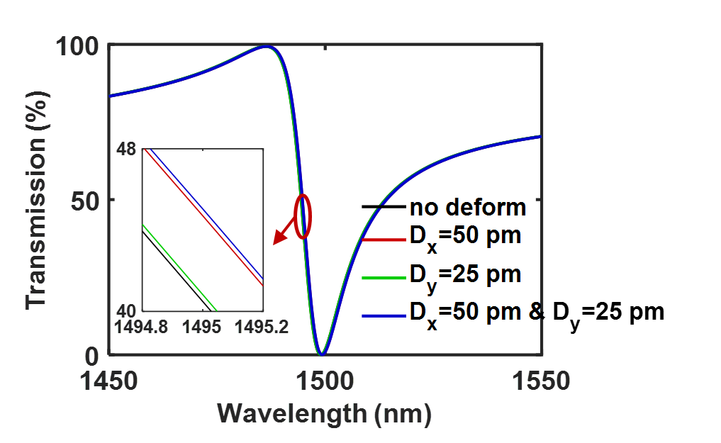

Fig. S10. Calculated transmission spectra for Si nanobar metasurfaces with slightly different structural parameters: $w=316 nm$, $L=580 nm$, $x_{0}=189 nm$ (black curve); $w=316 nm+50 pm$, $L=580 nm$, $x_{0}=189 nm$ (red curve); $w=316 nm$, $L=580 nm+25 pm$, $x_{0}=189 nm$ (green curve); $w=316 nm+50 pm$, $L=580 nm+25 pm$, $x_{0}=189 nm$ (blue curve);